Sprint 5 - Srihari Madhavan and Sai Roopesh

The following are the reports generated from the project database created by our team.

# Order the food group based on descending order of average calories present

This helps analyse which food group would have the highest calories present and can help dieticians and doctors to look into which food groups to avoid for weight loss.

Code:

**SELECT** group_details **as** 'Food group', **AVG**(energy_in_kcal) **as** 'Average energy in kcal'

**from** food_group fg

**join** food_description fd **on** fd.group_id = fg.food_group_id

**group** **by** group_details

**order** **by** **AVG**(energy_in_kcal) **desc**;

Output :

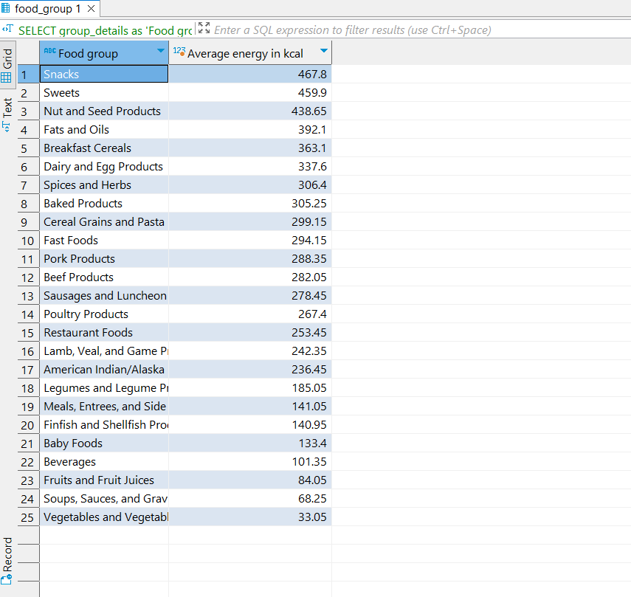

# List of all names and descriptions of food items

This report consists of all the names such as common name, manufacturing names or scientific name through which each food item is called, It is useful when we need a list of the food items and we need appropriate short names to call them by instead of their food_id or their brief decription.

Code:

**SELECT** common_name **as** name , fd.description

**FROM** common_name cn

**JOIN** food_description fd **ON** cn.food_id = fd.food_id

**UNION**

**SELECT** manufacturing_name **as** name ,fd.description

**FROM** manufacturing_name mn

**JOIN** food_description fd **ON** mn.food_id = fd.food_id

**UNION**

**SELECT** scientific_name **as** name ,fd.description

**FROM** scientific_name sn

**JOIN** food_description fd **ON** sn.food_id = fd.food_id;

Output:

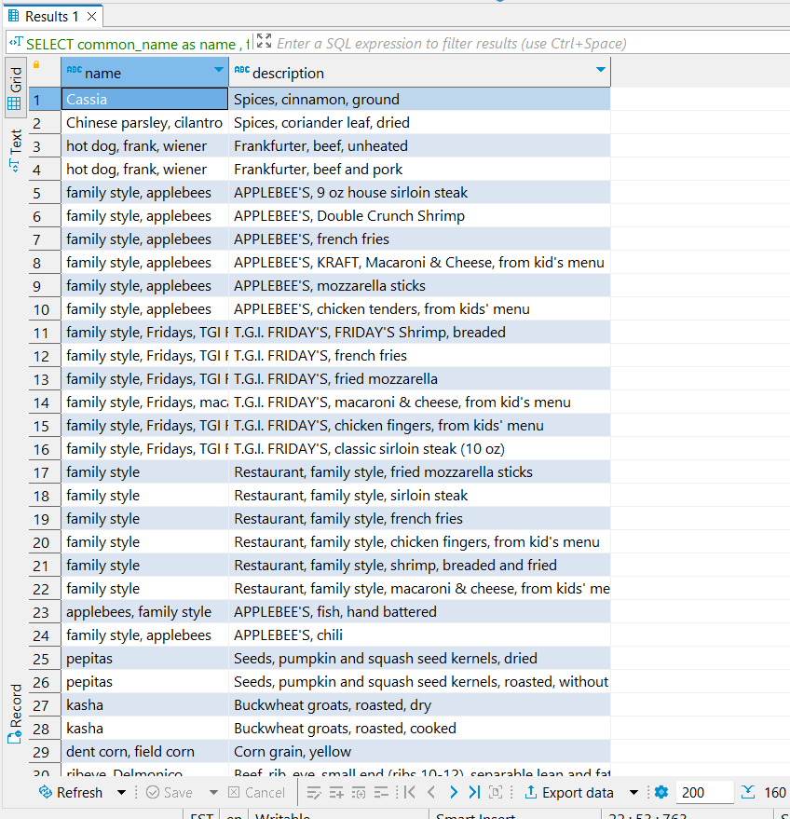

# % of Protein content to that of recommended content for food items

This report provides the % of recommended protein content each food item contains.

This report is important for dieticians and doctors to find which foods have high protein content so that they may be prescribed for people who practice weight loss or muscle gain

Code:

**SELECT** fd.description , 100\***round**(nc.nutrients_in_g/nl.recommended_daily_amounts,3)

**as** '% of Protein content to recommended content'

**FROM** nutrient_list nl

**JOIN** nutrients_contained nc **ON** nl.nutrient_id = nc.nutrient_id

**JOIN** food_description fd **ON** fd.food_id = nc.food_id

**WHERE** nl.nutrient_name **like** 'Protein%';

Output:

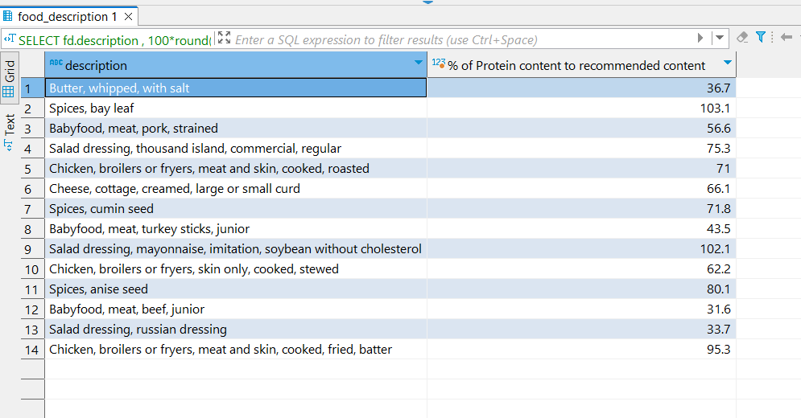

# Count the number of countries for each nutrient with atleast 3% prevalence of deficiencies

This report counts the number of countries, for each nutrient (like Calcium, vitamins, zinc), that have population percentage greater than 3% who are deficient to that nutrient

This can be useful for Organisations like the United Nations to look into how many nations require immediate care for food resources since the amount of help they can provide is limited and needs to be spent optimally.

Code:

**SELECT** nl.nutrient_name , **count**(country_name ) **as** 'Countries with > 3% deficiency'

**FROM** prominent_deficiencies_by_country pdbc

**JOIN** country_deficiency_relationship cdr **ON** pdbc.country_id = cdr.country_id

**JOIN** nutrient_list nl **ON** nl.nutrient_id = cdr.nutrient_id

**where** cdr.Prevalence_of_deficiency > 3

**group** **by** nl.nutrient_name ;

Output:

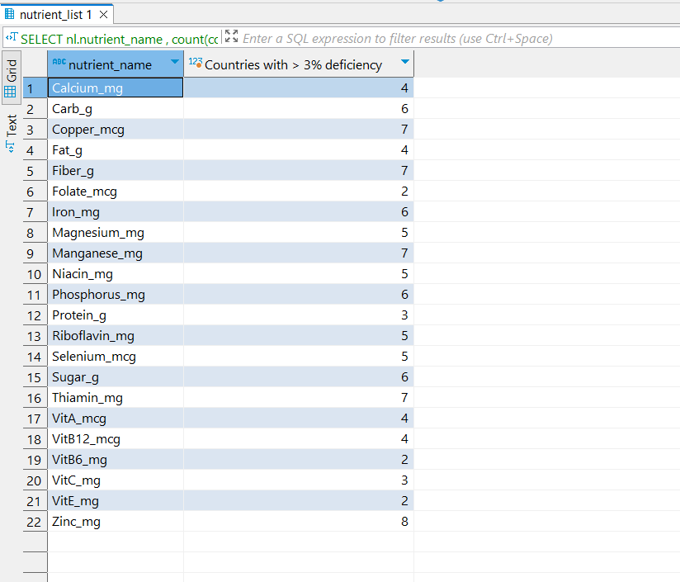

# Proportion of each food group in diets based on diet_food_details

This report informs us the proportion of each food group allowed in each diet. This is report is useful for dieticians to provide advice to patients on how much they can have of each food type for their diet.

Code:

**SELECT** fg.group_details ,dafp.diet_name ,

**case**

**when** dfc.diet_food_details = 'can be skipped' **THEN** 0.25

**when** dfc.diet_food_details = 'needed sometimes' **THEN** 0.5

**when** dfc.diet_food_details = 'essential' **THEN** 0.75

**end** **as** 'Proportion allowed in diet'

**FROM** food_group fg

**JOIN** food_description fd **on** fg.food_group_id = fd.group_id

**join** diet_food_combination dfc **on** dfc.food_id = fd.food_id

**join** diets_and_food_preferences dafp **on** dafp.diet_id = dfc.diet_id ;

Output:

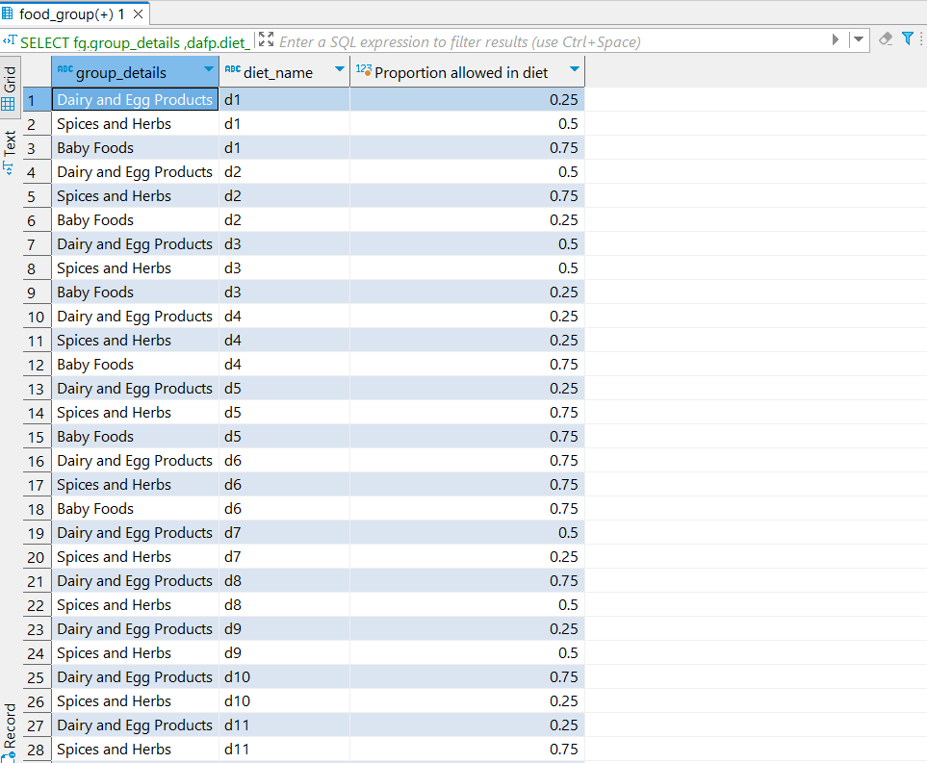

# What we’ve learned so far:

We learnt that planning, creating, and utilizing a Database is not an easy task by any means. During our project we worked long ours to make sure every step from drawing ERD diagrams, to generating reports for the sprint 5 were well executed to our best capabilities. We also learned how to import data into DBeaver and how to use Microsoft Visio and MariaDB. We also learned on how to look for different ways in which to generate a desired report from a database, looking into how to join multiple tables to get the desired output. Overall this project helped us peek into the big picture of how companies handle and work with mountains of data in their labyrinth of databases and how each and every report is generated through the combination of skill and hardwork.